**XGBoost (eXtreme Gradient Boosting)**

**1. What is XGBoost?**

* XGBoost is an optimized, distributed **gradient boosting** library designed for efficiency, flexibility, and portability.
* It's a highly successful implementation of the gradient boosting framework, often achieving state-of-the-art results on structured/tabular data.
* It builds upon the core ideas of gradient boosting (sequential model building, fitting residuals/gradients) but incorporates several significant enhancements for speed and accuracy.

**2. Key Features & Enhancements over Standard Gradient Boosting**

* **Regularization:** XGBoost includes L1 (Lasso, controlled by alpha or reg_alpha) and L2 (Ridge, controlled by lambda or reg_lambda) regularization terms directly in its objective function. This penalizes model complexity (number of leaves and leaf weights), helping prevent overfitting and improve generalization.
* **Parallel Processing:** While trees are still built sequentially (boosting), XGBoost can parallelize parts of the tree construction process internally (e.g., finding the best split across features), making it significantly faster than traditional gradient boosting implementations.
* **Handling Missing Values (Sparsity-Aware Split Finding):** XGBoost has a built-in mechanism to handle missing data. During training, it learns a default direction (left or right child node) for samples with missing values at each split, based on which direction maximizes the gain. This avoids the need for manual imputation.
* **Tree Pruning:** XGBoost grows trees up to a specified max_depth and then may prune them backward. It uses a gamma (or min_split_loss) parameter; a split is only made if the loss reduction (gain) from the split is greater than gamma. This acts as a form of post-pruning to control complexity.
* **Hardware Optimization (Cache Awareness & Out-of-Core Computation):** XGBoost employs techniques like organizing data into blocks and using cache-aware algorithms to optimize hardware usage, especially for large datasets. It can also handle datasets that don't fit into memory ("out-of-core").
* **Weighted Quantile Sketch:** For finding split points efficiently on large datasets, XGBoost can use an approximate greedy algorithm involving sketches (specifically, a weighted quantile sketch) to propose candidate split points effectively.
* **Built-in Cross-Validation:** XGBoost allows you to perform cross-validation at each boosting iteration, making it easier to find the optimal number of boosting rounds.

**3. Objective Function (Conceptual)**

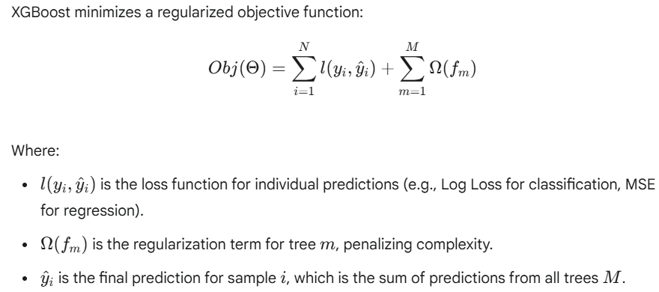

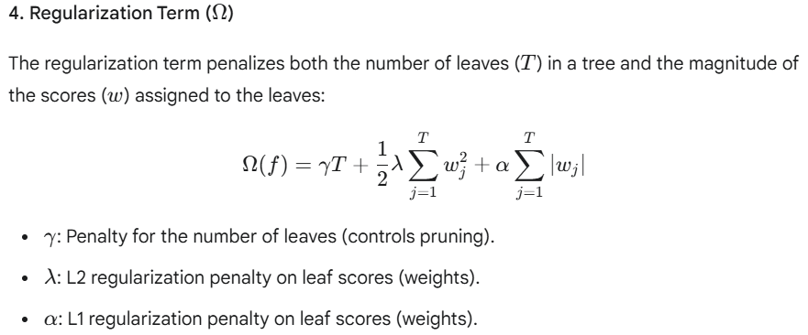

**5. Split Finding (Similarity Score & Gain)**

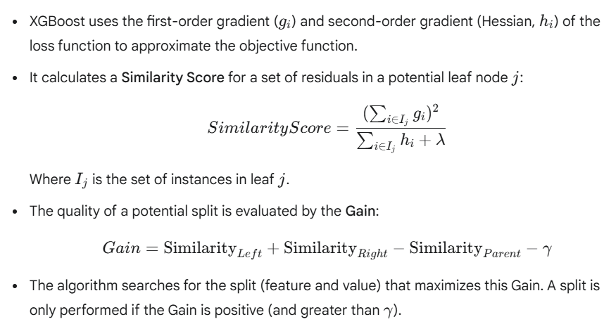

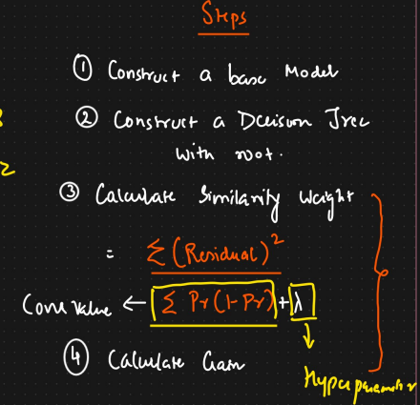

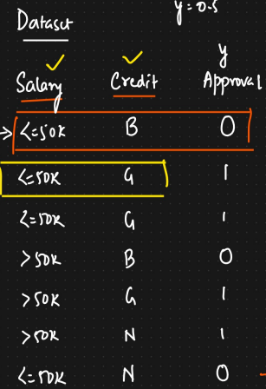

**Step 1-**

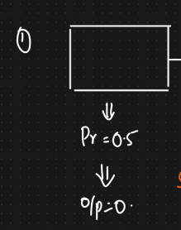

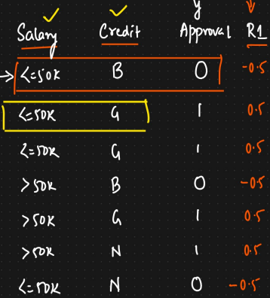

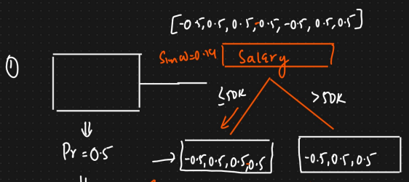

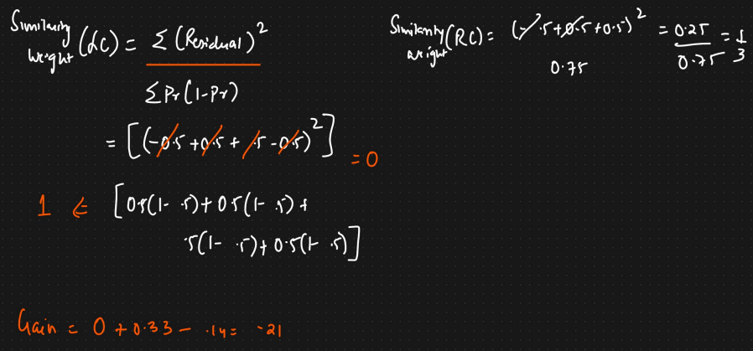

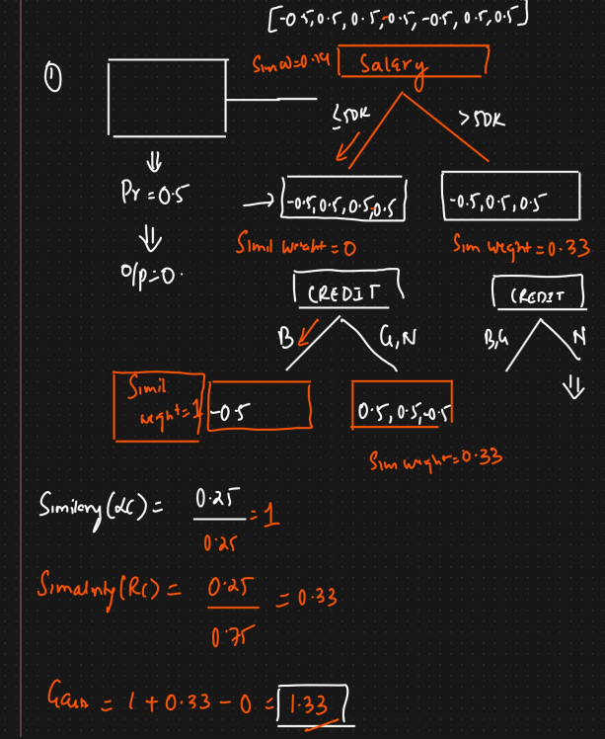

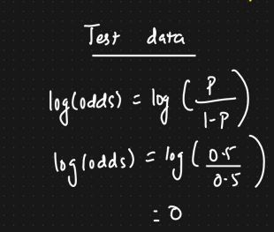

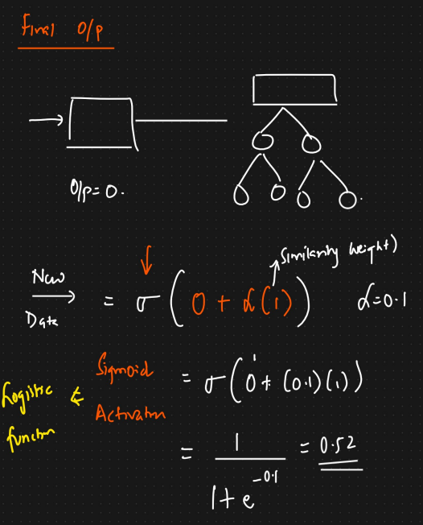

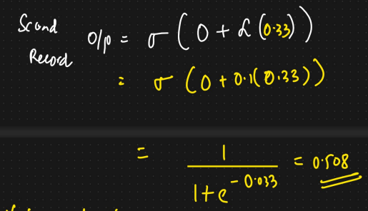

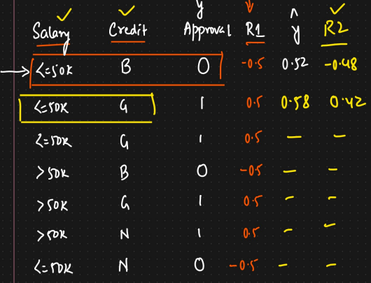

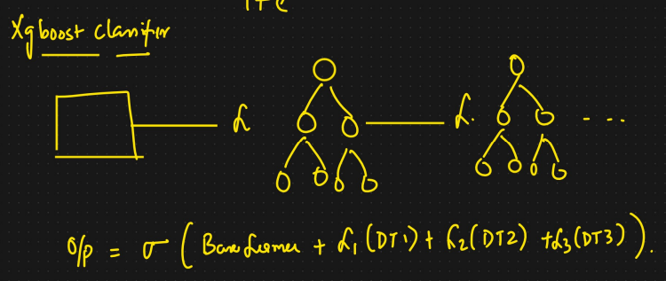

**6. Advantages of XGBoost**

* **Speed & Performance:** Generally faster and more efficient than standard Gradient Boosting due to parallelization and optimizations.
* **Accuracy:** Often yields higher accuracy due to regularization and optimized algorithms.
* **Regularization:** Built-in L1/L2 regularization helps prevent overfitting.
* **Missing Value Handling:** Intrinsic ability to handle missing data simplifies preprocessing.
* **Flexibility:** Supports custom loss functions and evaluation metrics.

**7. Disadvantages/Considerations**

* **Hyperparameter Tuning:** Still requires careful tuning of numerous hyperparameters, which can be complex.
* **Interpretability:** Like other tree ensembles, can be harder to interpret than simpler models.
* **Computational Cost:** While optimized, can still be computationally intensive, especially on very large datasets or with many boosting rounds.
* **Potential for Bias:** Like any ML model, can learn and potentially amplify biases present in the training data.

